Youth Ministry Pastoral Plan
Goal 1: To empower young people to live as joyful disciples of Jesus Christ in our world today by proclaiming the Good News of Jesus Christ through witness, word, worship, and formation
- Objective 1: Implement an age-appropriate Scripture study that will meet weekly outside of the normal youth group meeting (Recurring objective, begin in September of 2021)
- Objective 2: Implement an age-appropriate discipleship study within weekly youth group meetings that focuses on youth exploring what it means to be a disciple and how to live as a joyful disciple (Recurring objective, begin in October of 2021)
- Objective 3: Form youth on how to articulate their own testimony and practice giving that testimony to others within the curriculum for youth ministry (Recurring objective, begin in September of 2021)
- Objective 4: Partner with the Diocese of Charleston Vocations Office to implement a course of action for promoting vocations with youth in our parish (November 2021)
- Objective 5: Implement a young men’s vocation discernment group during Advent using the Melchizedek Project initiative resources (November-December 2021)
- Objective 6: Increase the participation of Fr. Oscar and Deacon Tim (and other clergy) in youth ministry (Recurring objective, begin in September of 2021)
- Objective 7: Implement discipleship groups for teens following the Sacrament of Confirmation (Recurring objective, begin in October of 2021)
- Objective 8: Require Confirmandi to participate in one parish ministry outside of youth ministry while preparing for the Sacrament of Confirmation (Recurring objective, begin in September of 2021)
Goal 2: To draw young people to responsible participation in the life, mission, and work of the Catholic faith community while helping them to know and reflect upon their God-given gifts and talents
- Objective 1: Evaluate and implement service opportunities surrounding the Corporal Works of Mercy into the curriculum for youth ministry (Recurring objective, begin in October of 2021)
- Objective 2: Create a youth leadership team that will conduct meetings, act as formation leaders, peer ministers, and more in youth ministry (January 2022)
- Objective 3: Develop a youth retreat team to plan and implement youth retreats throughout the year (i.e., Advent, Lent, and Pentecost retreats) (November 2022)
- Objective 4: Assign one youth to the pastoral counsel (August 2021)
- Objective 5: Ensure, through personal invitation, that all liturgical ministries have representation of youth February 2022)
- Objective 6: Implement service opportunities and formation surrounding the 7 Themes of Catholic Social Teaching into the curriculum for youth ministry (Recurring objective, begin in October of 2021)
- Objective 7: Implement the Called & Gifted Discernment Process with the youth leadership team (February of 2022)
- Objective 8: Host a yearly youth listening session, where youth will be able to speak to the Pastor, Youth Minister, Core Team, and Parent Advisory Board about their spiritual and personal needs (November 2021)

Goal 3: To foster the total personal and spiritual growth of each young person
- Objective 1: Integrate liturgical celebrations into the curriculum for youth ministry, such as Novenas, Stations of the Cross, and Adoration of the Blessed Sacrament on a regular basis (Recurring objective, begin in September of 2021)
- Objective 2: Plan and implement an annual Advent retreat for youth & families to participate in from St. James and the Myrtle Beach Deanery (November 2021)
- Objective 3: Plan and implement an annual Lenten retreat for youth & families to participate in from St. James and the Myrtle Beach Deanery (March 2022)
- Objective 4: Create a sub-ministry to foster intergenerational relationships which will pair youth with our golden agers (November 2021)
- Objective 5: Offer bi-weekly Tuesday night open hours ending with Youth Group, Mass and Holy Hour (Recurring objective, begin in September of 2021)
- Objective 6: Implement reunion opportunities a few weeks after each retreat for teens to continue to allow the spiritual flame to burn (Recurring objective, begin in December of 2021)
Goal 4: To provide greater outreach and evangelization to young people in our community by going to where they are and inviting them into relationship
- Objective 1: Continue and expand efforts to encounter youth via social media (September 2021)
- Objective 2: Evaluate and implement an evangelization curriculum for youth within the parish in hopes that they will go and evangelize in their schools, neighborhoods, and families (Recurring objective, begin in September of 2021)
- Objective 3: Implement monthly fellowship opportunities for both evangelized and non-evangelized youth to participate in, such as sporting events, concerts, movie nights, etc. (October 2021)
- Objective 4: Implement a youth Bible Study at Conway High School and Carolina Forest High School (October 2021)
Goal 5: To help youth recognize and appreciate the multicultural facet of our parish, community, and world
- Objective 1: Increase awareness of the opportunities for devotional practices that transcend culture, e.g., Adoration, novenas, Lenten fasting, May Crowning, Las Posadas, Stations of the Cross, etc. (Recurring objective, begin in September of 2021)
- Objective 2: Partner with the Diocesan Hispanic Youth Ministry Office to evaluate our current model of evangelizing Hispanic youth and implement a course of action for improvement in this area (December 2021)
- Objective 3: Ensure that any youth leadership teams are diverse (Recurring objective, begin in December of 2021)
Goal 6: To demonstrate commitment to youth within the parish and become a truly youth-ministering community by empowering the entire parish community in responsible participation in the formation of young people
- Objective 1: Reevaluate youth ministry budget and allocate money for retreats and speakers (August 2021)
- Objective 2: Send youth minister on one youth ministry training retreat/conferences per year (Recurring objective, subject to retreat/conference opportunities)
- Objective 3: Raise funds and purchase a van or small bus to be used as transportation for retreats, trips, and other outings for youth and the parish (June 2022)
- Objective 4: Incorporate the language and culture of youth into the worship and daily life of the Church via homilies, bulletin articles, and more (Recurring objective, begin in August of 2021)

Goal 7: To empower parents/guardians/families in their role as primary communicators of the faith to their youth
- Objective 1: Create a parent advisory board for youth ministry (October 2021)
- Objective 2: Create and distribute formation material that correlates with youth ministry formation to be used by parents to facilitate at home conversations and continuation of formation efforts (Recurring objective, begin in September of 2021)
- Objective 3: Host a yearly parent listening session for parents of youth to speak to the pastor, youth minister, core team, and parent advisory board about their needs for their youth and families (November 2021)
- Objective 4: Implement a formation study on a shared resource that teens and parents can attend together during Lent (March 2022)
Goal 8: To create a network of adult volunteers invested in the formation of young, joyful disciples
- Objective 1: Increase the number of adult core members between 5 and 8 (December 2021)
- Objective 2: Support and educate parish leadership to be aware of, and involved in, the spiritual and educational formation of youth via bulletin articles, online resources, and volunteer opportunities (Recurring objective, begin in September 2021)
- Objective 3: Create a prayer ministry comprised of adults that will pray for our youth on a regular basis (September 2021)
- Objective 4: Highly encourage all adult youth ministry formation leaders to register for and complete one youth ministry certificate of their choosing (there are several certificate options) (Recurring objective, subject to certificate opportunities)

WHAT IS THE MELCHIZEDEK PROJECT?
The Melchizedek Project is a nationwide initiative to form small discernment groups that provide information and support for young men as they discern a vocation to the Catholic priesthood. Most young Catholic men lack the in-depth information they need to prayerfully discern the priesthood. Small discernment groups provide a good support structure for men as they “dive deep” into the discernment process.

More than 1,100 Melchizedek Project discernment groups have been formed nationwide involving more than 12,000 young men. Hundreds of seminarians credit the program for giving them the clarity to take the next steps toward the priesthood.
The groups are fruitful for two main reasons. First, because they foster good relationships between priests and young men. Second, because they approach priestly discernment with the wisdom and guidance in To Save a Thousand Souls, which helps men reach a mature decision about their vocations.

Structure
The discernment groups meet seven times per semester for about 90 minutes. A discussion guide in the back of To Save a Thousand Souls provides an excellent format for each meeting, with questions corresponding to each chapter in the book. Very little preparation is needed for leaders or participants, as key passages of the book are read aloud and discussed.

Our Overall Mission
The overarching aim of The Melchizedek Project is to help men hear the call of Jesus Christ and discover their true vocations. This initiative is funded by The Foundation for Priestly Vocations and is run by Vianney Vocations.

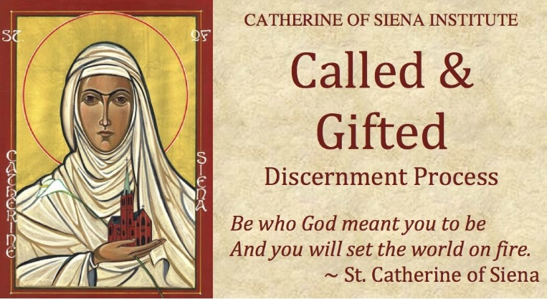
The Called & Gifted™ Discernment Process has been used since 1993 by over 100,000 lay, ordained, and religious Catholics and other Christians around the world. It is designed to help Christians discern the presence of charisms in their lives. Charisms, or spiritual gifts, are special abilities given to all Christians by the Holy Spirit to give them power both to represent Christ and to be a channel of God's goodness for people. Whether extraordinary or ordinary, all charisms ought to be exercised in the service of God. All three parts of the process are necessary for discovering where you are gifted.
- Part One is the Called and Gifted workshop, which lays the foundation for the beginning of discernment. During the initial Called & Gifted workshop series the participants will take the Catholic Spiritual Gifts Inventory.
- Part Two is the one hour gifts interview, an invaluable part of the process.
- Part Three helps you begin discernment in the real world. It will teach you how to:
  - develop charism experiments, evaluate your results, and identify ways you learned to control life as a child that get in the way of using your charisms as an adult.

